Pegasus Class Summer Project

Your homework challenge over the summer holidays is to create a poster, model or booklet about a Prehistoric Monument or settlement in Britain to go on display in your new classroom. Prehistory means that it is so old there isn’t any written evidence about it. Instead, we have to find evidence that they left behind such as villages, hillforts and monuments. This project will help you with our Topic in the Autumn term:

The Stone Age to the Iron Age

Some monuments you could find out about are:
- Stonehenge
- Maiden Castle
- Skara Brae
- Grimes Graves
- Bloodgate Hillfort
- Tarr steps

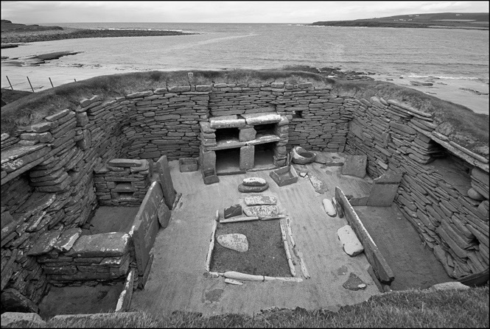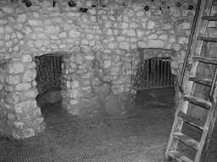
accident  accidentally  actual  actually  address  answer  appear  arrive  believe  bicycle  breath  breathe  build  busy  business  calendar  caught  centre  century  certain circle  complete | consider  continue  decide  describe  different  difficult  disappear  early  earth  eight eighth  enough  exercise  experience  experiment  extreme  famous  favourite February  forward  forwards  fruit | grammar  group  guard  guide  heard  heart  height  history  imagine  increase  important  interest  island  knowledge  learn  length  library  material  medicine mention  minute  natural | naughty  notice  occasion  occasionally  often  opposite  ordinary  particular  peculiar  perhaps  popular  position  possess  possession  possible  potatoes  pressure  probably  promise  purpose  quarter  question | recent  regular  reign  remember  sentence  separate  special  straight  strange  strength  suppose  surprise  therefore  though  although  thought  through  various  weight  woman  women

Please continue to read as much as possible, practise your year 3 and 4 spellings and learn your time tables over the summer holidays - this will help you in Year 3. Don’t forget to have fun and go on some adventures.

Have a lovely summer holiday,
Miss White

